

**DEPARTMENT OF ELECTRONICS AND COMMUNICAION ENGINEERING**

**Subject: DIGITAL ELECTRONICS& MICROCONTROLLERS (ECH308B-T/P)**

**Branch: CSE**

**Course: B.Tech 5th SEM**

**TUTORIAL -8: Sequential Circuits**

CO3. Analyze different types of digital electronic circuits using various mapping and logical tools and know the techniques to prepare the most simplified circuit using multiple mapping and mathematical methods.

1. What is the sequence of flip flop considering initial state Q = 0?

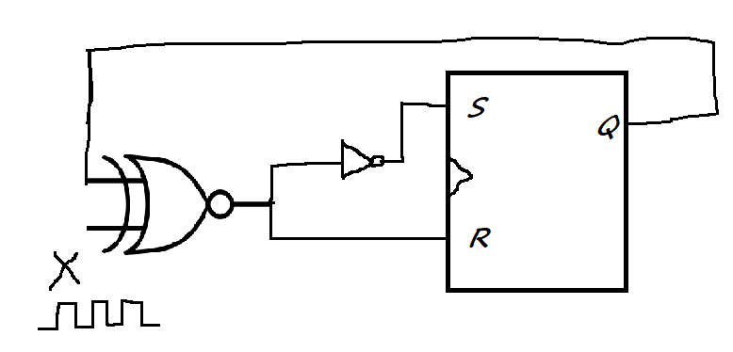

1. In the figure the initial state of Q is 0. The output is observed after application of each pulse. The output sequence at Q is

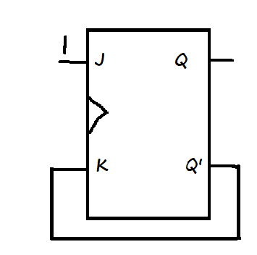

1. The mod 5 Counter counts Q2 Q1Q0 = 000, 001, 010, 011 and 100. The truth table of the flip flop used is given. Obtain the State Table of mod 5 counter.

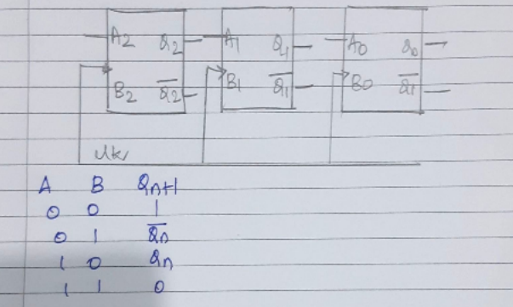

1. Design a positive edge triggered 3 bit Ripple Up Counter.